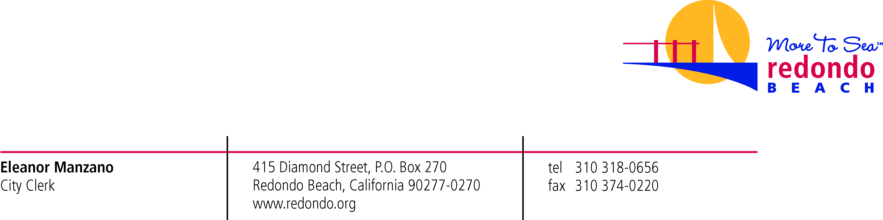

September 19, 2019

VIA ELECTRONIC MAIL
MuckRock News
78839-77253032@requests.muckrock.com

RE: Public Record Request, Case 32485 – Ring Promo

Dear Ms. Haskins

Regarding your public records request received August 12, 2019 – regarding the Ring Promotional agreement which is attached to this email, also please find responsive documents to your request.

As you may be aware, the Public Records Act permits a local agency to withhold from disclosure records that are exempt from disclosure, or portions of such records that are covered by an exemption. (Cal. Gov’t Code §6250 et seq.) There are documents responsive to your request that are protected by the attorney-client privilege and attorney work product, and thus exempted from disclosure under the Public Records Act pursuant to Government Code §6254(k). (see also Evidence Code §§ 952, 954) There were also responsive documents which were redacted because they contained personal/private information which is exempt from disclosure pursuant to the privacy provisions of Article 1, Section 1 of the California Constitution incorporated into the Public Records Act exemptions through Government Code Section 6254(k). These determinations have been made by Assistant City Attorney Cheryl Park.

Yours truly,

Annamarie Porter, CMC
Records Management Supervisor

