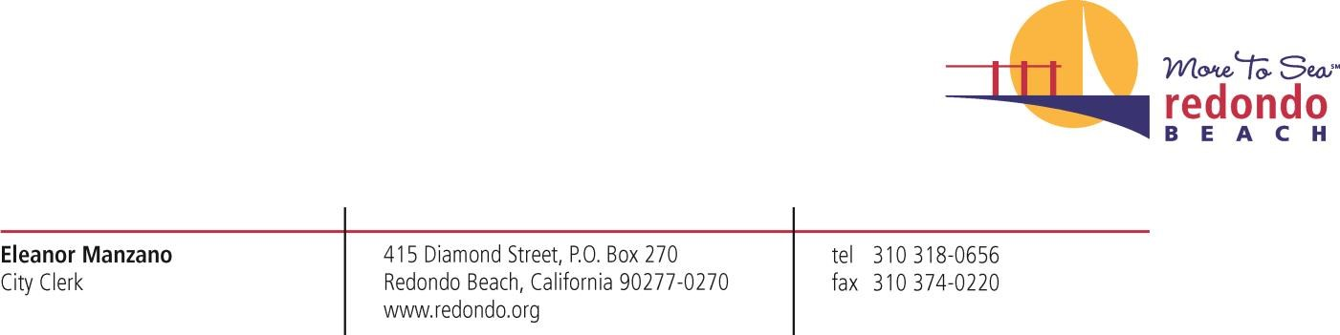

September 5, 2019

VIA EMAIL
Ms. Caroline Haskins 78839-77253032@requests.muckrock.com

Re: Public Records Request – Production
Case No. #32485
Promotional Discount Agreements with Ring

Dear Ms. Haskins:

Regarding your public records request of August 12, 2019 for records regarding Promotional Discount Agreements with Ring, as you may be aware, the Public Records Act permits a local agency to withhold from disclosure records that are exempt from disclosure, or portions of such records that are covered by an exemption. (Cal. Gov’t Code §6250, et seq.) While the City is not withholding any records at this time, because the City has not completed its review of all responsive records, exemptions may apply. If we determine that records will be withheld or redacted on the basis of an exemption under the Public Records Act, we will so notify you in writing of the basis for withholding or redacting that information. Where the City can reasonably segregate and redact exempt information from a record, we will do so and produce the disclosable information.
The City will promptly make these materials available once it completes its review of the documents. Additional time is necessary to complete its compilation and review; thus, the City expects to produce the batch of responsive documents by Thursday, September 19, 2019.
If you should have any questions, please contact Annamarie Porter at (310) 318-0656 Ext. 2204 or via email at Annamarie.porter@redondo.org.
Thank you,
Annamarie Porter, CMC
Records Management Supervisor

